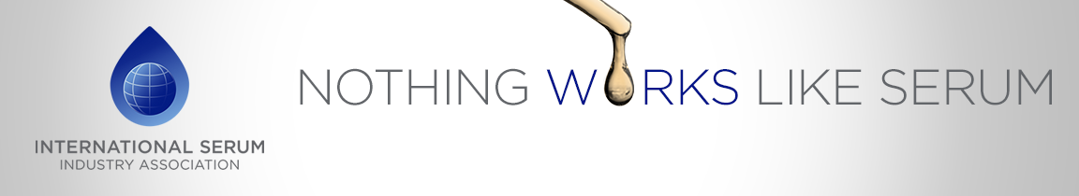
14th ISIA Annual Meeting
Lisbon, Portugal
April 24th & 25th 2019
Payment Form

Company Name/ Organization Name:
(one form per attending COMPANY/ ORGANIZATION)

Regular Member: Associate Member: Non-Member: Invited ISIA Guest:

Name/s of Registrant/s | Member Fee | Assoc Member Fee | Non-Member fee  (1st year only) | Non-Member fee  (2nd year only) | Invited  ISIA Guest Fee
1. | nil | $585 | $420 | $895 | nil
2. | $385 | $585 | $895 | $895
3. | $385 | $585 | $895 | $895
4. | $385 | $585 | $895 | $895

REGISTRATION FEES TOTAL: $

Name/s of Diner/s | Dinner Fee  All Attendees | Invited ISIA Guest Fee
1. | $145 | nil
2. | $145
3. | $145
4. | $145

DINNER FEES TOTAL: $
Total your Registration Fees
& your Dinner Reservation Fees for all attendees……………………………TOTAL: $

Payment: In Advance - Payment deadline - MARCH 22, 2019
Complete the form - Make your payment - Email form to julia@serumindustry.org

Please check the appropriate payment box below!

Remittances by PayPal/ Credit Card https://www.serumindustry.org/
Above is the link to the ISIA website home page where you will see the link for the PayPal/ Credit Card option.
Remittances should be mailed to:  ISIA AGM  c/o Axenia BioLogix  800 Business Park Drive  Dixon CA 95620-4309 USA | Remittances should be wired to:  Bank of America  SWIFT: BOFAUS3N  Routing: 026009593  Account No: 07032-44805  Please include a 5% wire fee (not to exceed US$50) and email Steve Judd (judd@serumindustry.org) so that your payment is properly credited.

